CLASS - V
Kendriya Vidyalaya No 1 Ishapore
Subject - English
Holiday Homework (autumn break)
Session -2023-24
Read the instructions and answer the following.
All of these tasks should be done in A4 size paper. Margin should be maintained.

1.
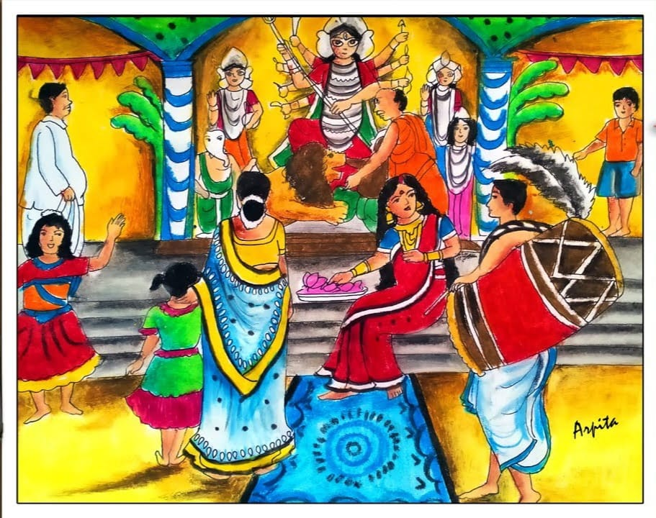
Describe the picture and write 10-12 lines about it. You can express your own thoughts and feelings about it.
2. Using dictionary write any 20 words with proper meaning.
3. Compose a story with your own words and thought. Word limit 120-150 words.
4. Read 4 pages everyday and enhance your reading habit.

हिंदी
1. कोको की माँ ने उसके लिए चावल की रोटियाँ बनाईं।”
एक ही चीज़ के विभिन्न रूपों के अलग-अलग नाम हो सकते हैं। नीचे ऐसे कुछ शब्द दिए गए हैं। उनमें अंतर बताओ, और उनके चित्र चिपकाओ/ बनाओ ।
चावल, धान, भात, मुरमुरा, चिउड़ा
साबुत दाल, धुली दाल, छिलका दाल
गेहूँ, दलिया, आटा, मैदा, सूजी

2. -भारत में कोई चीज़ खरीदने-बेचने के लिए रुपए का इस्तेमाल होता है| निचे दिऐ देशों की मुद्राऍ लिखो-

1. सऊदी अरब –
2. जापान -
3. फ्रांस
4. इटल –
5. इींग्लैंड -
6. जर्मनी
7. चीन
8. श्रीलंका
9-.नेपाल
10. म्यांमार

MATHS
PROBLEM SOLVING ABILITY:
Visit at least 10 Puja Pandals take their photographs and solve few questions as follows:
- Find the total cost of the Pandal?
- Find the total cost of idol of Maa Durga?
- Find total expenditure of lightings for the Pandal?
- Find total cost of Prasada they have bought for Puja?
- Finally estimate the total expenditure of the Durga Puja for 5 days? Also paste the photographs of the Pandal.
EVS
DISCOVERY OF FACTS:
- What is the price of petrol and diesel in your area?
- Why are the prices of petrol and diesel going up?
- If we cook food using wood or uples (cow dung cakes), what difficulties shall we face?
- Where is diesel used?
- What would happen if you don’t get petrol or diesel for a week in your town?
- Suggest some ways to save oil.
- In one month how much petrol, diesel, kerosene, LPG is used?
- Ask your elders when they were young what fuel were then used to cook food at home?

